JAMES ALLEN brother of JOHN ALLAN.
The spelling Allen has been used throughout to separate him out from other Allans. His name was spelled Allen on his death certificate , and his children spelled it that way– as did his brother John in the Navy.
Both James and John were born in Strabane, County Tyrone. [Aboukir Muster Roll May 1815 for John.)

Search for James, young brother of our John – found, his death in 1884, and Death Certificate.

The breakthrough was to find in the Hocken Library an “Index of Irish Settlers to Otago Southland” collected by Michael Rombouts, a genealogist. James is named in it, on the “New Era” and born Strabane, Co. Tyrone. The listing also names a daughter Isabella married to Robert Dodd.

https://freepages.rootsweb.com/~nzbound/genealogy/otago.htm

We know that James and his family were on the New Era, the ship name is recorded in the death notice for his wife Janet McGuire in 1857.

Otago Witness 27 September 1856

On her death certificate, the Informant for Janet McGuire was Adam Oliver, Taieri Settler (and son in law of John Allan.) Adam Oliver’s name makes it fairly certain that this is the brother. [NZ-BDM]
Daughter Isabella Allen and her husband Robert Dodd are found in Wyndham [in Nat Archives ‘Papers Past’; Otago Witness; and NZSG Kiwi Index.] I looked for James Allen in Wyndham on the basis of the Dodd connection, and found a likely name, age and location, however he wasn’t with the Dodd family, rather he died while staying with “his son-in-law Wm Carpenter”.
All newspaper clips via PapersPast, NZ National Library.
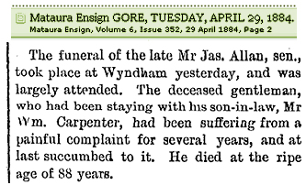
Wyndham Cemetery 3.00 Block II
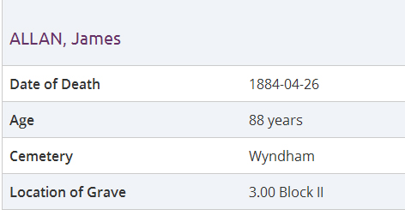
Carpenter: there is no recorded marriage between a Carpenter and an Allen or Allan. But a year after William Carpenter’s death his wife Mary Jane put a poem in the Southland Times to commemorate her beloved husband, and so we have her first name.
Mary Jane Carpenter’s death notice in 1900 says she was born in County Tyrone, Ireland, died aged 62, so about right age, right place - and her father James Allen visiting in 1884.
William Carpenter of Tamlet Farm, Mimihau, was also Ulster Irish, from Co. Antrim, b abt 1832.

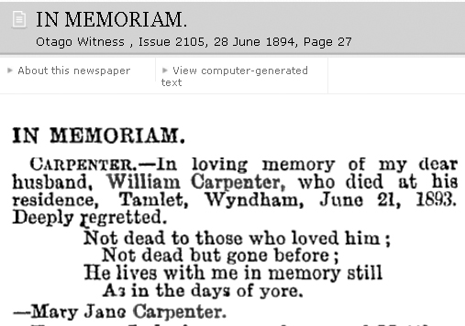
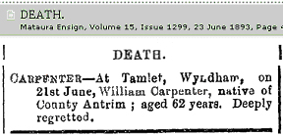

1893.
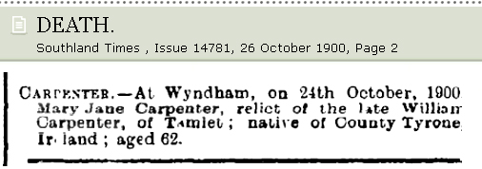
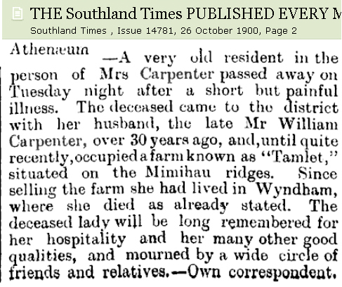
1900.

Mary Jane Carpenter, wife of William Carpenter. born in Co. Tyrone, Ireland, died aged 62 (b abt 1838).
They are buried together in Wyndham Cemetery Plot 72 Block 1.
Her obituary in the Southland Times says that she “will be long remembered for her hospitality and her many other good qualities.”

No apparent children.

Wyndham cemetery [Southland cemeteries web site, District Council]
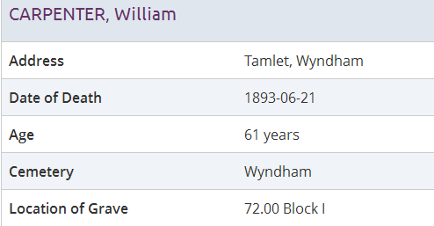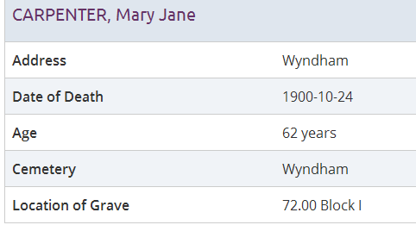

William Carpenter, Electoral Rolls: Wyndham
(1869 &1870 &1871 & 1872 & 1873 & 1874 & 1875 & 1876 (77, 78 Dn) & 1880 & 1881)
- 1876 - Freehold Wyndham District 100 Acres.(1876)
- 1880 - Freehold sections Sections 22, 23, 38, 40 and 29, Block 1, Wyndham District.
- 1884 - Freehold sections Sections 22, 23, and 38, Block 1, Wyndham District.
It would make sense that Mary Jane Carpenter, wife of James’ son-in-law William Carpenter was Mary Jane Allan, but the only appropriate marriage on the books is:

Marriage certificate – Widow. Witnesses John Harris, express driver, and Sarah A Harris. D.M. Stuart, Knox Church.
Previous marriage, in NZ BDM records.
Marriage certificate - witnesses Alexander Anderson and Robert Dodd. Registry Office Dunedin. . John Gillies.
Death:
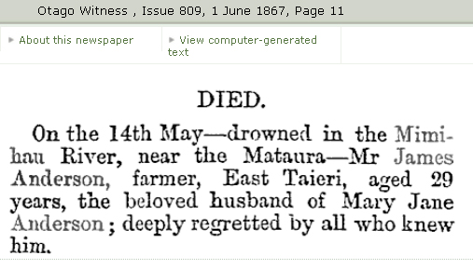
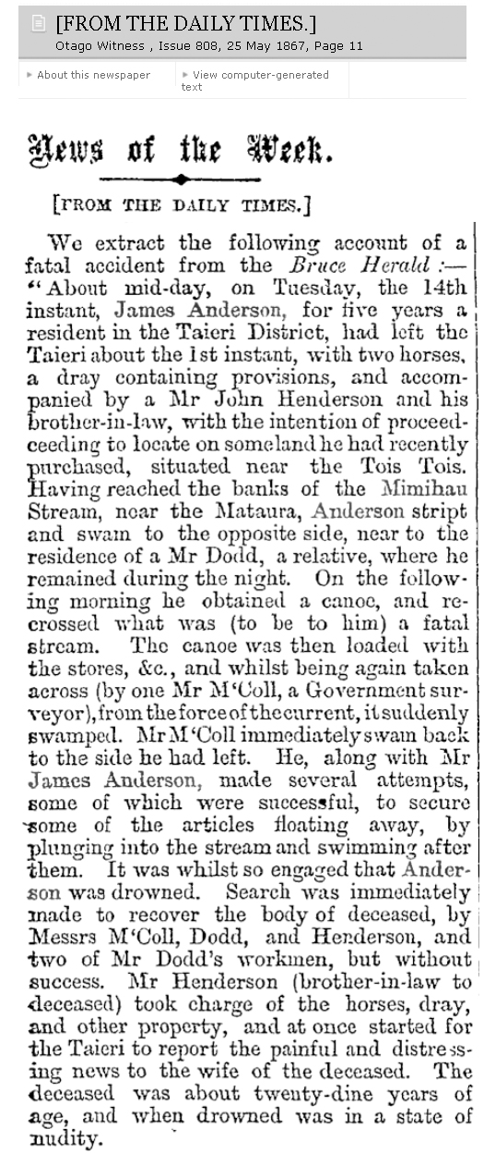

Robert Dodd was his brother-in-law.
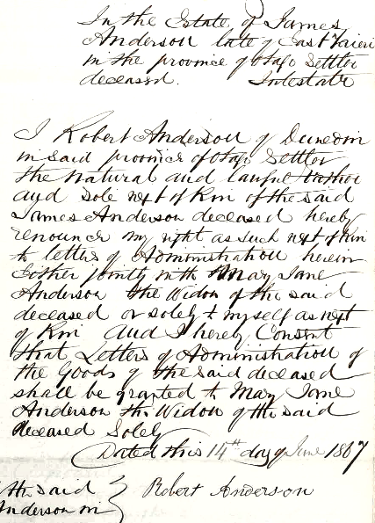
ANDERSON James. The Administration refers to James Allen, and River Section 20 which was “Edymore”.

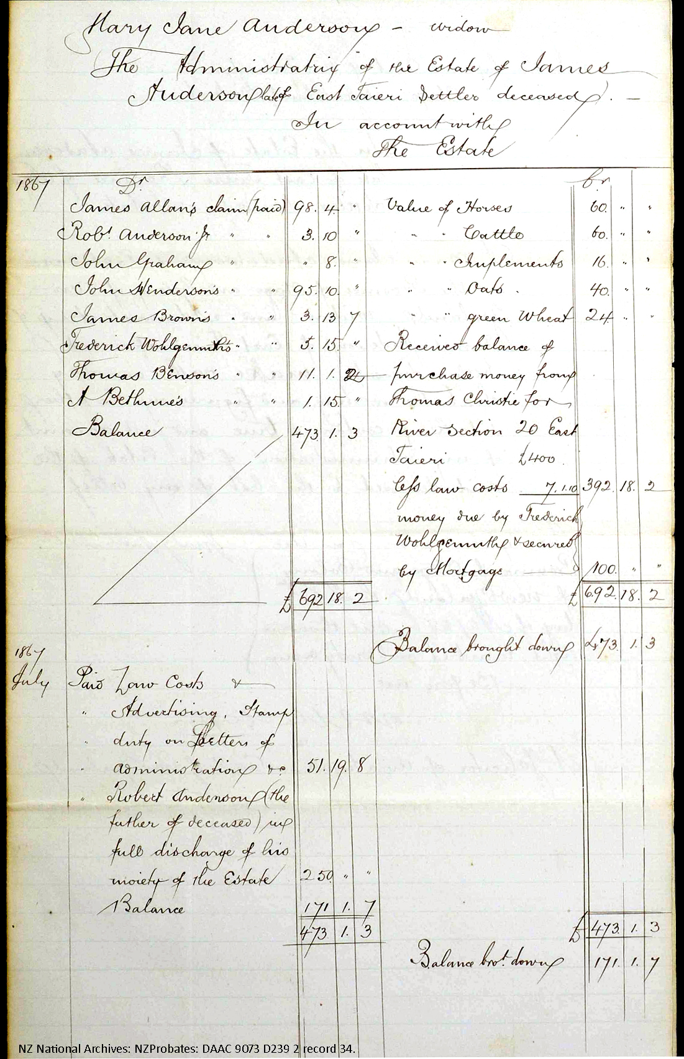
James Allen who died in Wyndham in 1884 aged 88 was born abt 1796, while brother John was probably born in 1792. James would be only 4 or 5 yrs old when John headed off to the Navy.

What we know for sure is,
- James Allen brother of John Allan, to New Zealand on the New Era with wife and five children, as First and Second Cabin passengers. The New Era docked at Wellington and the Allen family came on down to Otago on the Gazelle, arr. 28 Jul 1856.

“ARRIVAL OF THE ‘NEW ERA’ PASSENGERS AT OTAGO”. Otago Witness July 28th 1855

“..... the Gazelle in search of cargo. By the latter vessel we have received a small addition to our number of some 25 passengers, who left Great Britain in the New Era, and were transferred to the Gazelle at Wellington. Our new arrivals are mostly friends of old colonists, and have been induced by their friends here to join us.
Passengers on Gazelle: Todd, Lorimer, Brenner, Allan & family, Familton, Kirkwood, Bell family, Healey.

‘New Era’: First and Second Cabin Passengers
ALLAN, Mr, Mrs, and five children

Janet nee McGuire, wife of James Allen and a passenger on the “New Era”, died at East Taieri on Sep 19 1856, of Consumption, aged 51. Witness to death certificate, Adam Oliver, Taieri Settler. She was born in Strabane, County Tyrone, Ireland. See death notice and certificate above, p1.

Margaret Allan died aged 25 in East Taieri, Sept 8 1858, daughter of James Allan, settler. “Information communicated by Letter – Robt Chapman, Dep. Registrar.”), could this be a daughter catching TB from her mother? [Death found in a “Burials” archive, Hocken Library.]

No gravestone found in East Taieri for either Janet (nee McGuire), nor for Margaret.
But on death in 1884, James Allen had four living children, not five.

In 1861 James Allen bought River Section 20, East Taieri, and named it “Edymore”. It is near Allanton, within the block bounded by Riverside Rd, Murray Rd, the Taieri River and the railway line, the land has since been re-divided. Edymore, the original, is a farm and townland close to Strabane in Co. Tyrone, Ulster, and is the odd name that started this search.
Source of clip, PapersPast, NZ National Library
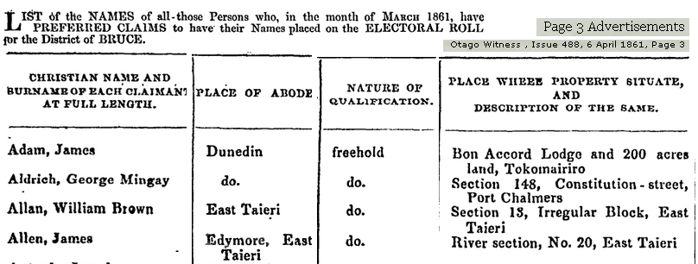

River Section 17 (not 20) “known as Edymore” was sold 20 May 1869 by “James Allan Jnr.”, in a mortagee sale. James Jnr. may be another of the five children: Edymore farm may have been made up of more than one block.
Edymore.
River Sections 17 and 20 are under the newer Lot 1, Lot 2, Lot 3, Keith Hall estate.
[ Part, map by S Park 1916 revised 1930, “Dunedin, East Taieri etc Survey District”. National Archives, Dunedin.]

Edymore - in lower centre of map, is a farm area south of Strabane, Co. Tyrone, Ulster. R. Mourne.
[British War Office. GSGS 4127. 1st. 4 Strabane and Dungannon. 1940. 1:126720. ex VisionOfBritain map site.]
Dodd: Isabella, daughter of James Allen, married Robert Dodd (spelled Dodds in marriage record) on 13 Oct 1858 in Dunedin, they farmed at Wyndham and had four children.

The entry for James Allen in the Rombouts List of Irish Settlers (see p 1.) may come from a descendant of the Dodds since they are the only family named. [Information contributed in 2002 by Margaret Godfrey, 189 Middleton Road, Kew, Dunedin, ph. (03) 487 6700 – but not in phone book now.]

Marriage of Isabella Allen and Robert Dodd:
NZBDM 1858/1447 Isabella Allan married Robert DODDS. Somewhere the surname has lost its final “S”
NZ Society of Genealogists Member Certificate CTF 57061, Isabella Allan married to Robert DODDS 13 Oct 1858 Dunedin. Also named on this certificate, James Allan and Robert Stevenson.

Children of Isabella and Robert Dodd: [from NZ BDM]
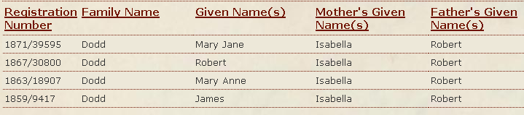

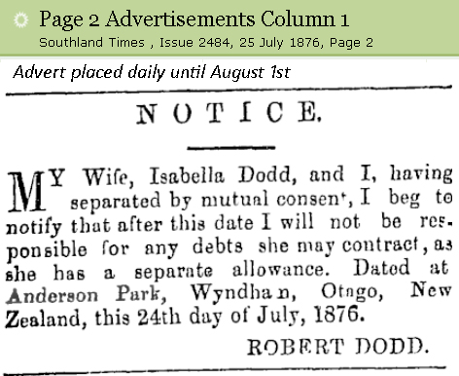

1876

Robert and Isabella Dodd are buried together in Plot 192 Block 10, Invercargill Eastern Cemetery:
- Robert Dodd died 19 Dec 1896 aged 65
- Isabella Dodd nee Allen died 25 Sept 1915 aged 79
- son Robert Dodd died 8 Feb 1891 aged 24
- dau Mary Jane Dodd d 1 August 1888 aged 16

Son James Allen Dodd (b 1859) died 9 Oct 1921 aged 66. He and his wife Catherine nee Campbell are buried in Wyndham Cemetery Plot 8 Block II. The Tripp family (Orepuki) are descendants, as is
Isabella Janet Dodd m to Alexander CROSBIE Gore 28 Apr 1904 (CTF 34842-022 - & 05 May 1923)
She died 26 Apr 1925 Gore aged 42 = b 1883. May be dau of James.

Dau Mary Anne Dodd (b 1863) married Robert George CARSON, farmer, in 1892, she died on 21 Jan 1906 age 42, and is buried in Wyndham Cemetery Plot 85 Block 1. Robert remarried in 1926, to Jane McLauchlan; he d. 1944 aged 77, buried at Wyndham cemetery Plot 71 Block 1.

Allen / Allan: “James Allen jun., of the Taieri, … Mr Allan” bought Thistledown and Mimihau farms in April 1884. He thus became a neighbour to his cousin Mary Jane Carpenter. This is James Allan (Jim), Janet McKay Allan’s elder brother, the dairy farmer, orchardist and bee-keeper. He would have been at Wyndham that week for the funeral of his great uncle James, on 28 April 1884
It is confusing that two men are called James Allan Jun. in the newspapers.

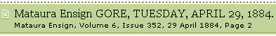
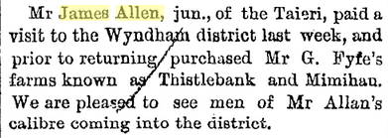
Jim Allan (not Allen) of the Holmes bought Thistlebank.

James Allen Snr., farmer, aged 88, died of cancer and general debility. Born Strabane, Co. Tyrone, In NZ 26 years. Married at abt age 35 to Janet McGuire. Informant, William Carpenter son-in-law.

His father’s name, JOHN Allen.

James Allen, brother of John, isn’t in “The Taieri Allans” except for one reference in childhood, that John was one of three children, Margaret, John, and James “who later joined his brother in NZ”.

There is one more child in James’ family, not identified. The death certificate above gives
Living Issue:
- 2 sons 38 years 35 Years
- 2 daughters 43 years and 40 years. These don’t quite match “age at death” formal records, William Carpenter may have been quite unsure of the ages of his in-laws.

Thus in April 1884,
Female aged 43 = b. 1841 - Isabella Dodd - d aged 79 in Sep 1915, thus b abt 1836
Female aged 40 = b. 1843 - Mary Jane Carpenter - d aged 62 in 1900, should be b. abt 1838-39
Male aged 38 = b. 1846 - male son Allen - ? James Allen Jnr., age 38 in 1884, death not known.
Male aged 35 = b. 1849 - male son Allen - ? age 35 in 1884, name and death not known.

Margaret Allen who died aged 25 in 1858 at East Taieri (b abt 1833) is most likely the other child in the family, and by her age the eldest.
_________________________________________________________________
Jan Kelly 186 Faulks Rd, RD 2 Wanaka 9382. ejkelly@clear.net.nz, (03) 443 4337
James Allen.

Family –

