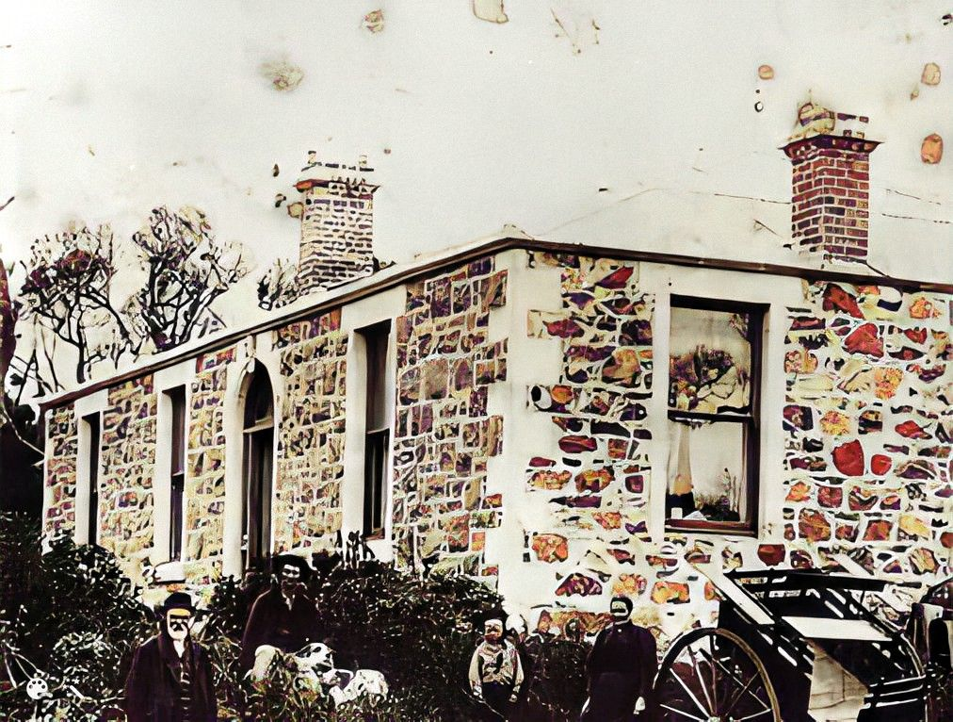

NZ Descent Line Photo Album

for Craig Sargison

Allan Sargison
20 September 2021

Contents
Photos Index 2
Sargison Family 3
Dick Family 5

Photos Index
Figure 1 Painting by Allan Gerald Dick 2
Figure 2Henry (Harry) Griffin Sargison (seated) & son James Henry 3
Figure 3 James Henry Sargison & Georgina Betson Cunningham wedding 3
Figure 4 Georgina Betson Cunningham 3
Figure 5 Sister Mary Ann Steele 3
Figure 6: Eric as boy 4
Figure 7: Eric Sargison & Doreen Dick wedding 4
Figure 8: Ereic WW2 4
Figure 9: Eric and Doreen first date (arranged by Hope) 4
Figure 10: Eric Dunback picnic 4
Figure 11Eric, Craig & Goliath, Waikouaiti 5
Figure 12 Eric, Craig near Queenstown 5
Figure 13 William Sargison & Helen Eason 5
Figure 14 Joseph Dick, Sarah Kerr and family 5
Figure 15 Joseph Dick& daughters Gladys, Gwendoline and Hazel. 5
Figure 16 Hope Dick and May Jolly 6
Figure 17 Family travelling 6
Figure 18# Generations - Mary Havard(Bayliss, Doreen Dick & May Jolly 6
Figure 19 Doreen's 21st. 6
Figure 20 May & Hope's 50th wedding anniversary 6
Figure 21 Doreen in Octagon 7
Figure 22 Craig, Doreen & Allan, Morrison St. 7
Figure 23 Dick/Sargison picnic, Dunback 7
Figure 24 Mary Hannah Havard (Bayliss) 7
Figure 25 Naseby Bach 8
Figure 26 Craig, Consul, @ Waitaki valley 8

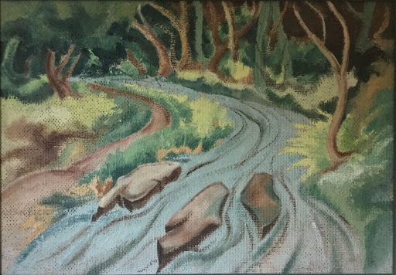
Figure 1 Painting by Allan Gerald Dick

Sargison Family
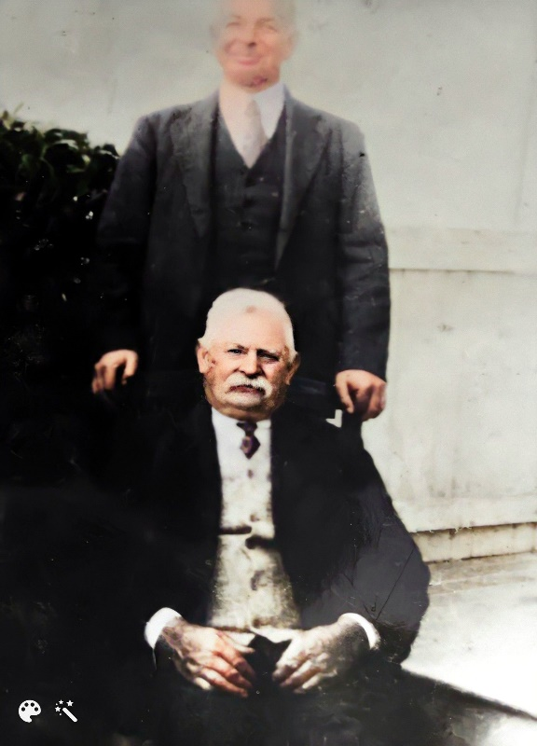
Figure 2Henry (Harry) Griffin Sargison (seated) & son James Henry
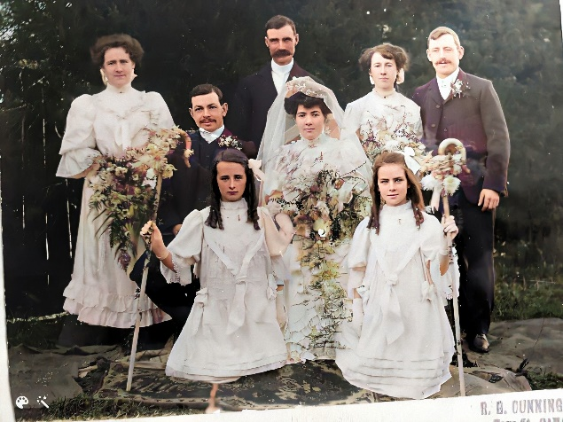
Figure 3 James Henry Sargison & Georgina Betson Cunningham wedding
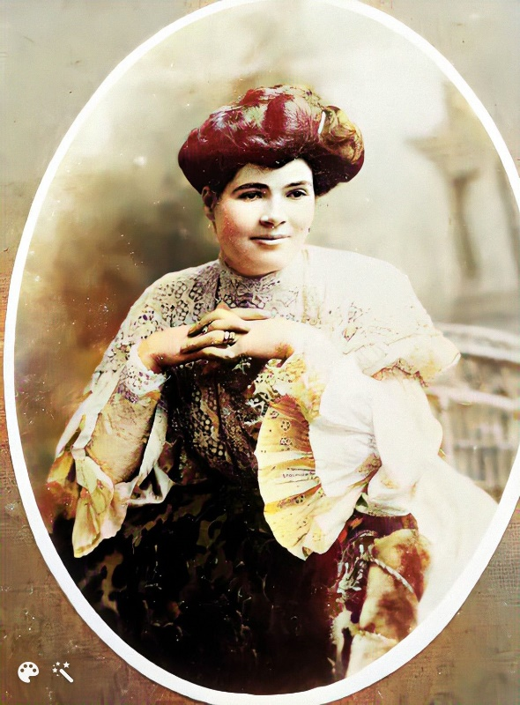
Figure 4 Georgina Betson Cunningham
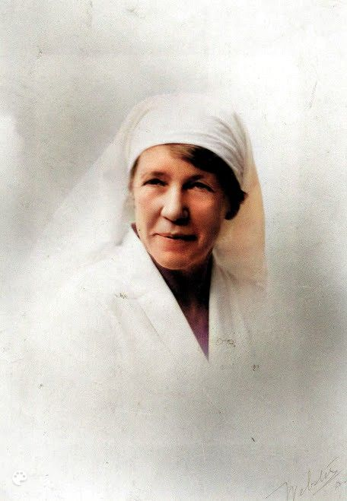
Figure 5 Sister Mary Ann Steele
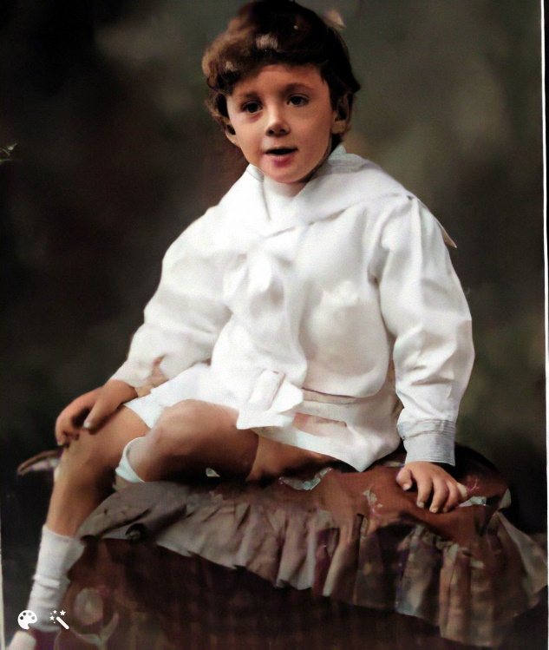
Figure 6: Eric as boy

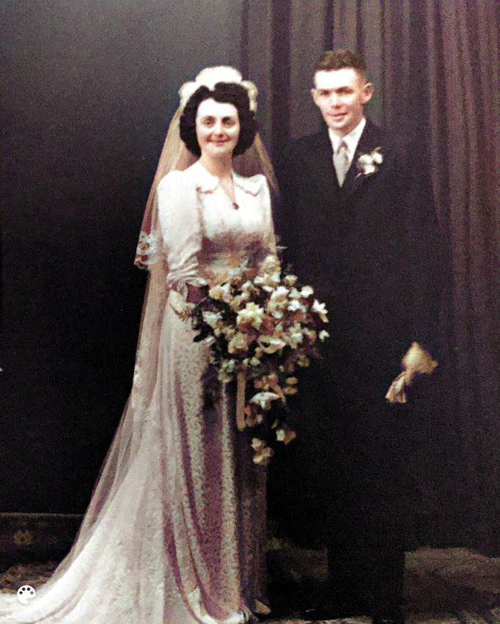
Figure 7: Eric Sargison & Doreen Dick wedding

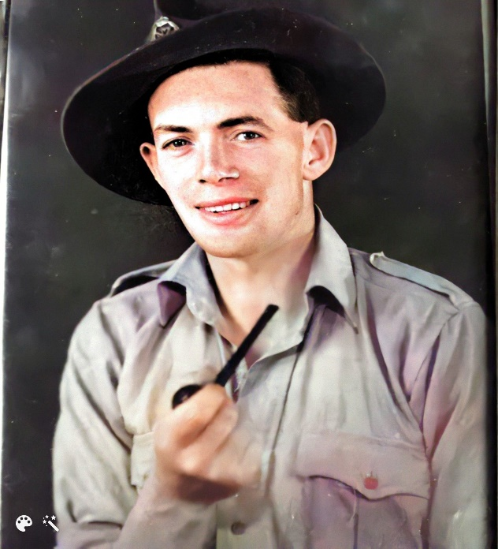
Figure 8: Ereic WW2
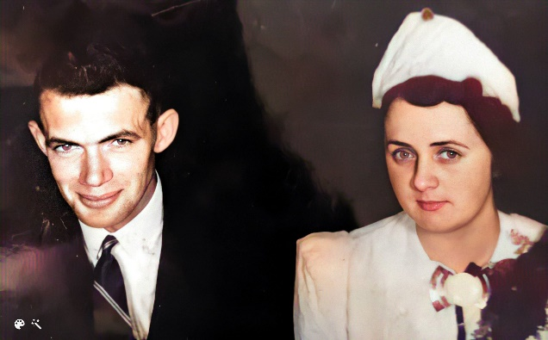
Figure 9: Eric and Doreen first date (arranged by Hope)
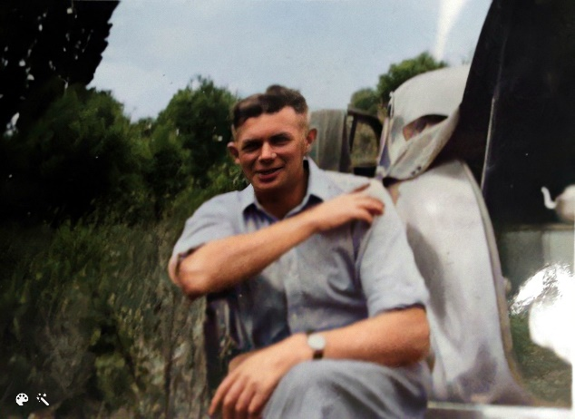
Figure 10: Eric Dunback picnic

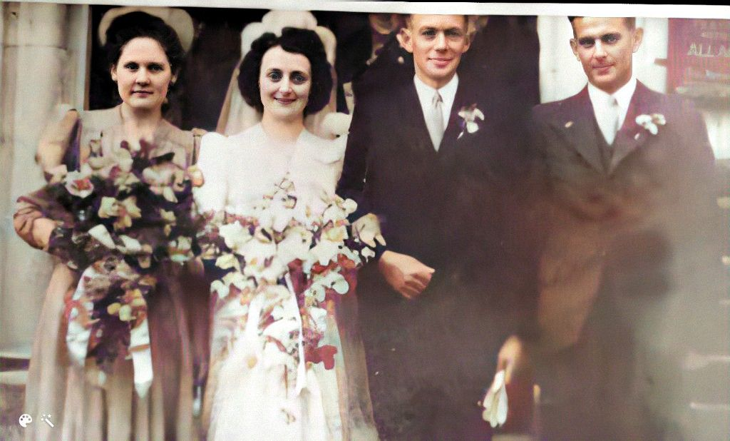

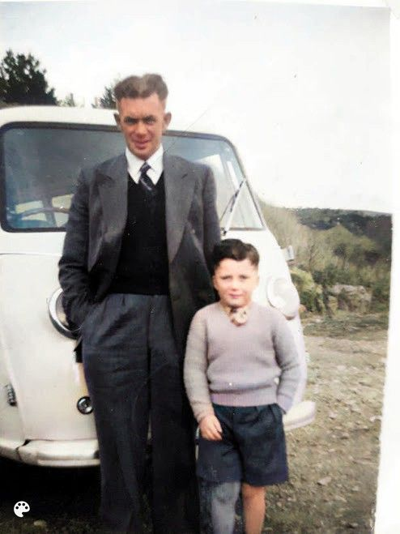
Figure 11Eric, Craig & Goliath, Waikouaiti
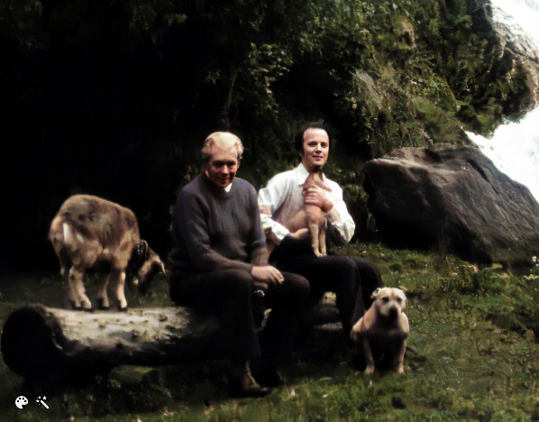
Figure 12 Eric, Craig near Queenstown

Dick Family
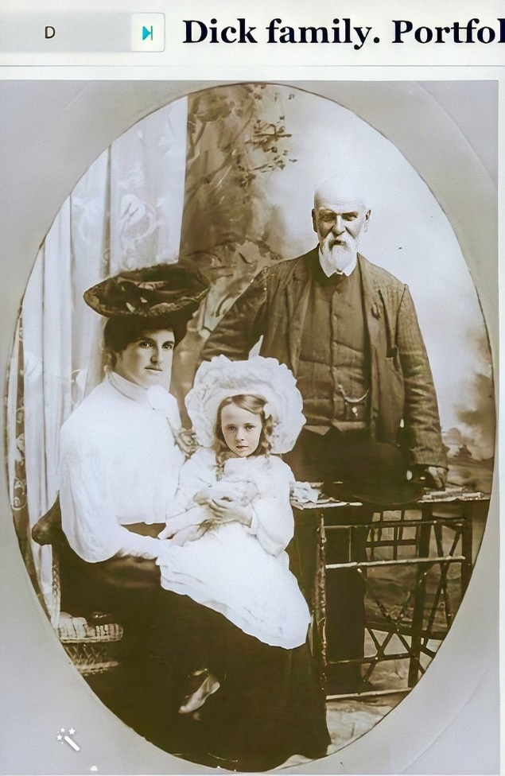
Figure 13 William Sargison & Helen Eason
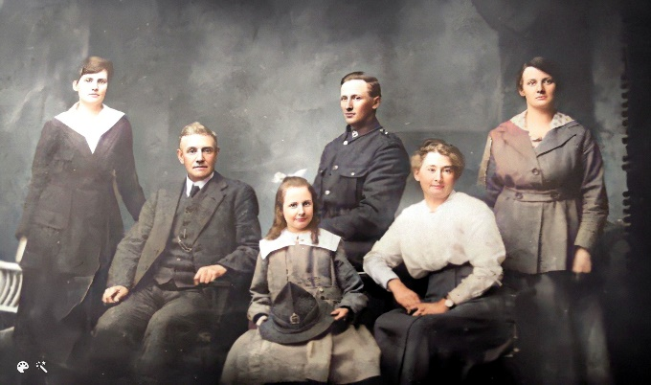
Figure 14 Joseph Dick, Sarah Kerr and family
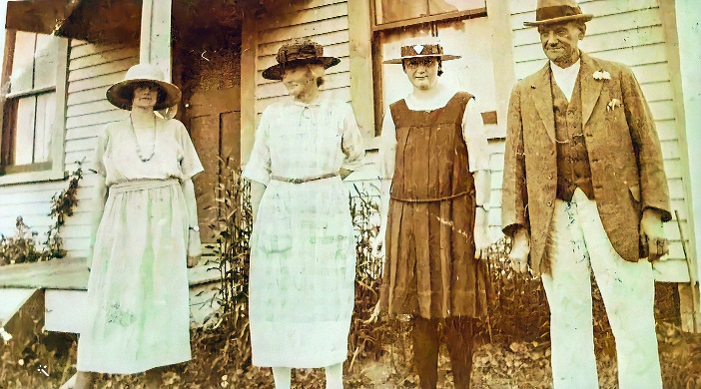
Figure 15 Joseph Dick& daughters Gladys, Gwendoline and Hazel.

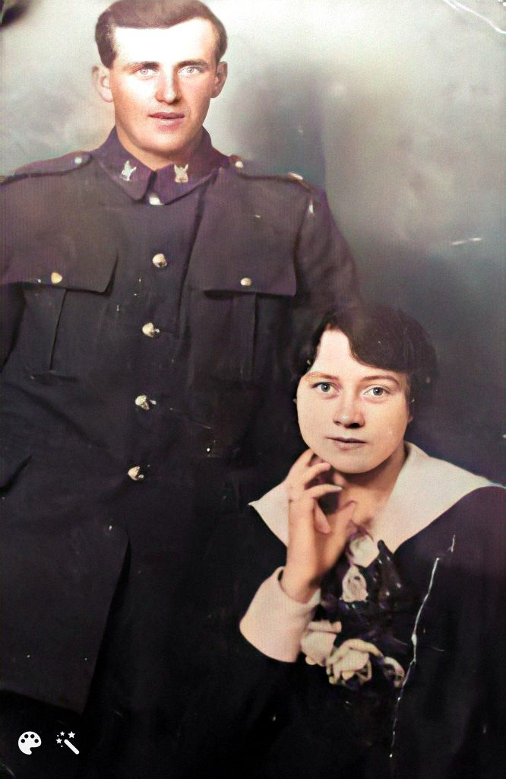
Figure 16 Hope Dick and May Jolly

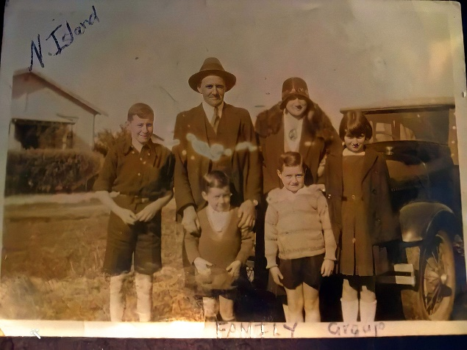
Figure 17 Family travelling
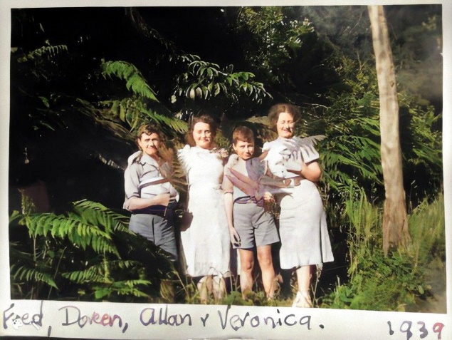

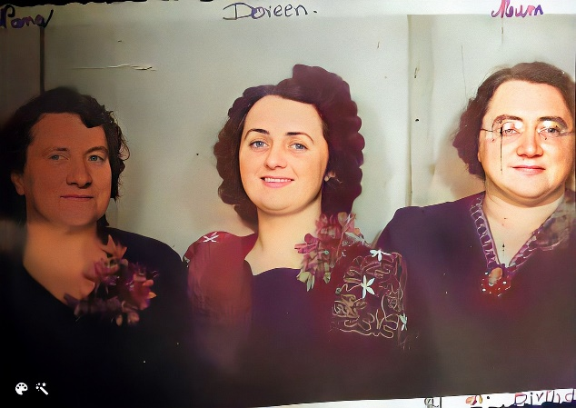
Figure 18# Generations - Mary Havard(Bayliss, Doreen Dick & May Jolly

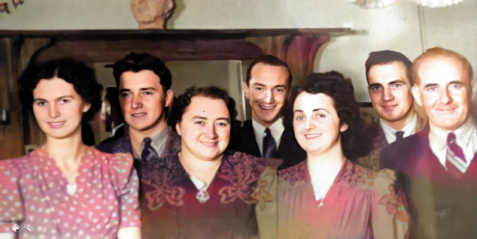
Figure 19 Doreen's 21st.
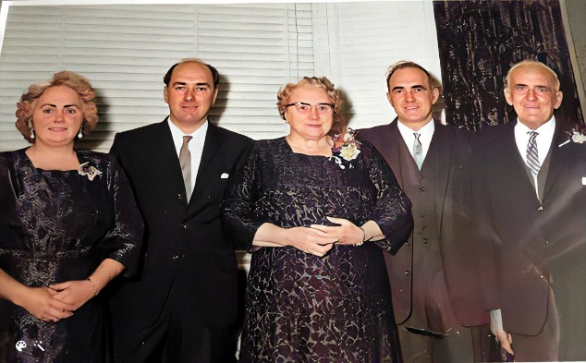
Figure 20 May & Hope's 50th wedding anniversary
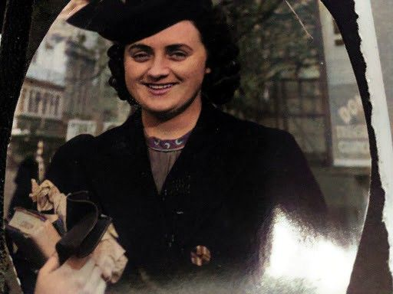
Figure 21 Doreen in Octagon

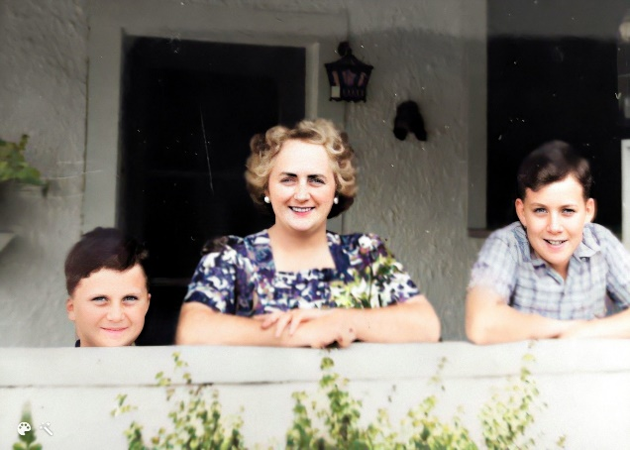
Figure 22 Craig, Doreen & Allan, Morrison St.

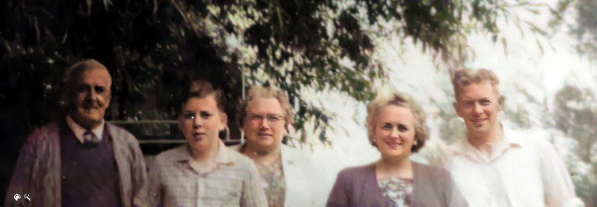
Figure 23 Dick/Sargison picnic, Dunback

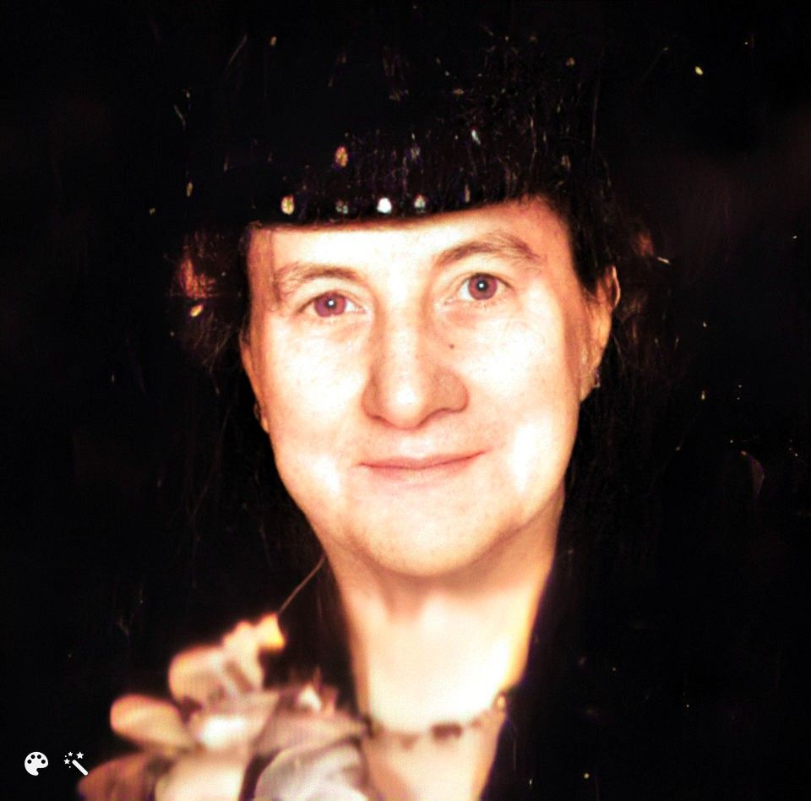
Figure 24 Mary Hannah Havard (Bayliss)
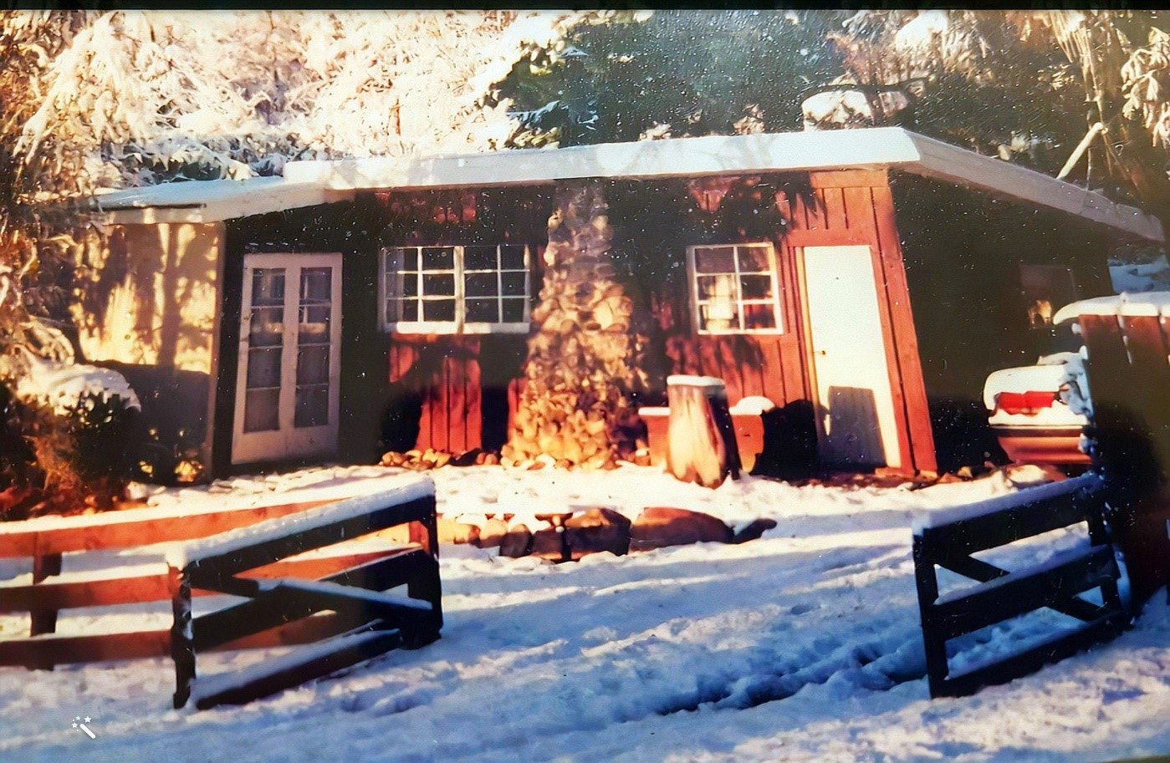
Figure 25 Naseby Bach

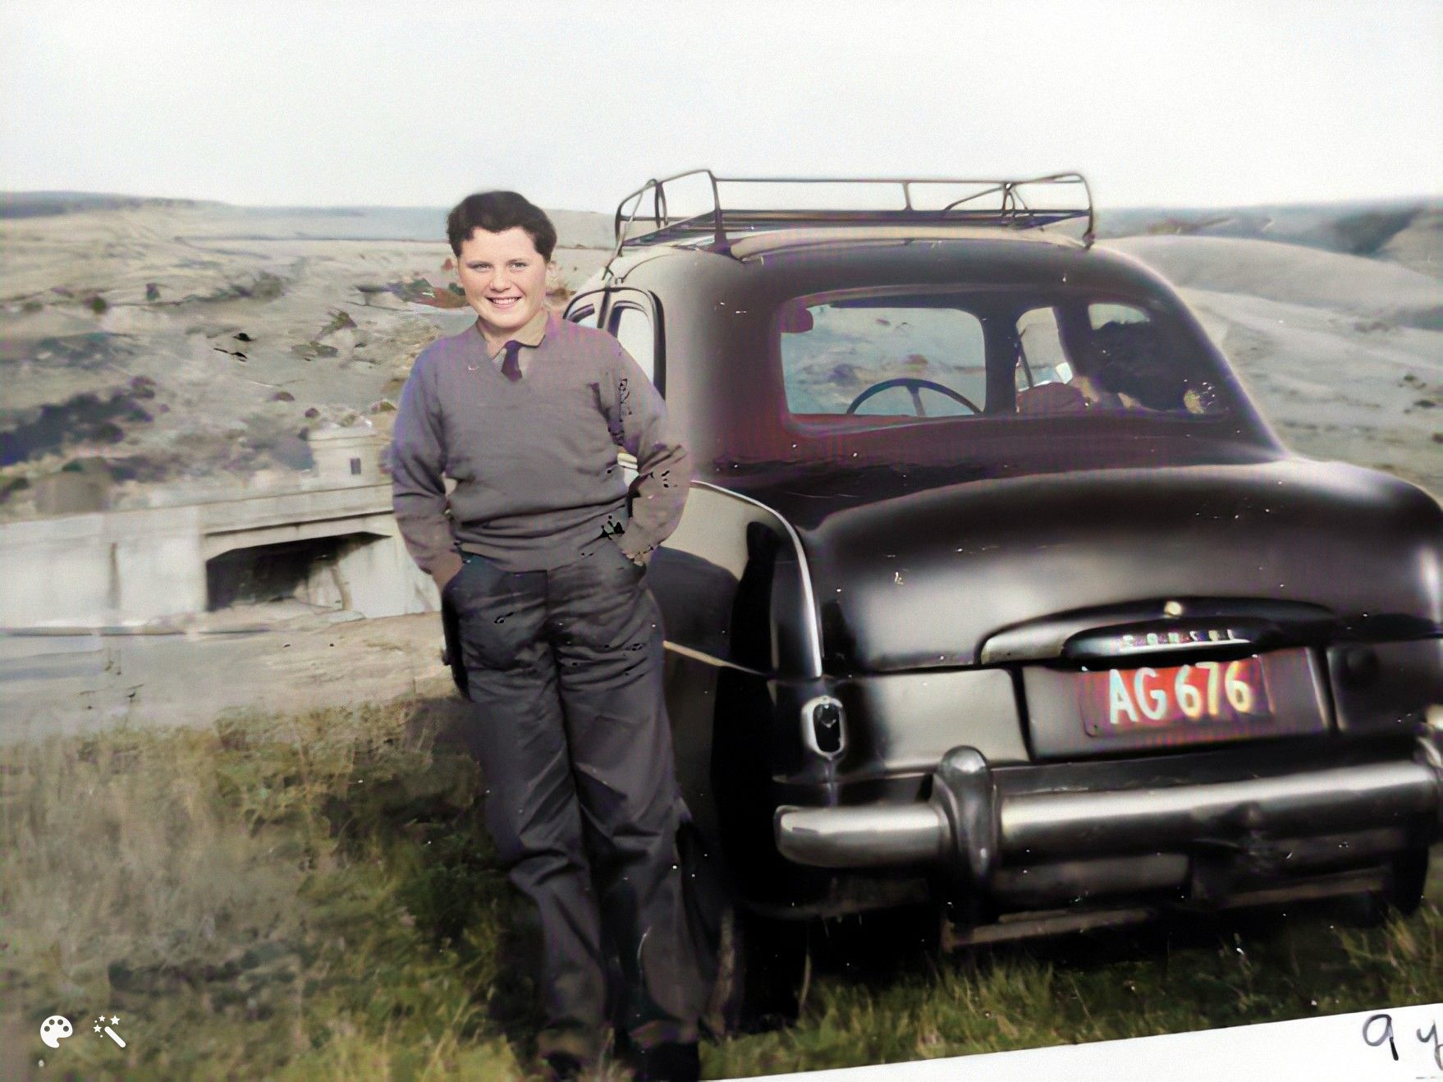
Figure 26 Craig, Consul, @ Waitaki valley

